**Experiment No. 03**

**Experiment Name: Implementation of Loops and IO**

*Course title: Programming Language II(Java) Lab*

*Course code:*

*Spring 2025*

**Date of Submission**:



**Submitted to-**

###### **Md. Rafsan Jani**

*Assistant Professor*

*Department of Computer Science and Engineering*

|  |  |  |
| --- | --- | --- |
| **Sl** | Class Roll | Name |
| 01 | 2023000010001 | Md. Samaul Islam |

**Problem-1:** Input 3 integers and print the smallest among them.

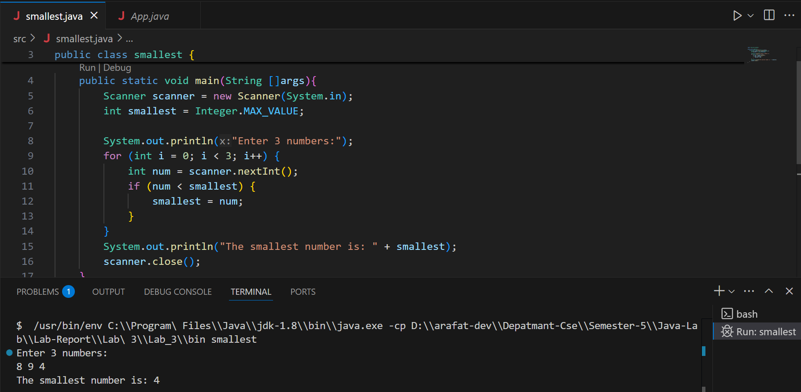

**Problem 2:** Input 4 integers and print their average.

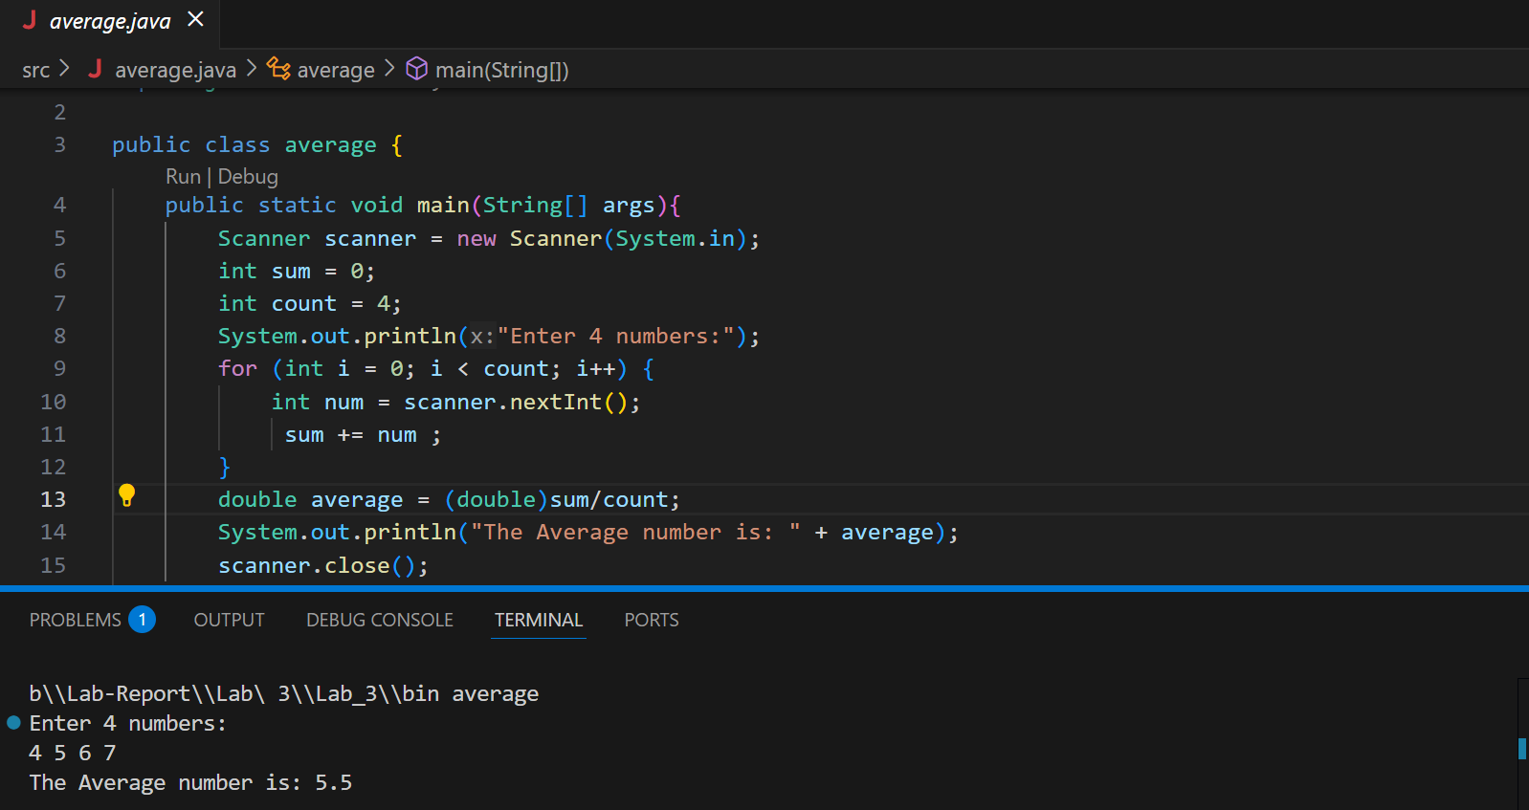

**Problem 3:** Input an integer N, then draw a diamond shape of 2N-1 lines using asterisks (*)

